**Bitcoin Timeline: Final Project Video**

In essence, our visualization is an interactive timeline of Bitcoin’s price over the course of its lifetime. This timeline is split into two primary components, the Bitcoin Price line chart and the list of events in Bitcoin’s history. Each of these components contain numerous visual affordance to help guide the user through the visualization as effectively as possible. The goal of this visualization is to allow a layperson without much technical knowledge of Bitcoin to understand the history behind the cryptocurrency in however much detail they prefer. Some insights a user may discover could be tying some specific event in Bitcoin’s history to a price crash or boom, and therefore understanding the future trajectory of the currency if/when history repeats it. The data for Bitcoin’s price history come from <https://blockchain.info/charts/market-price> while the list of events was manually collected from various news websites (the specific article for each event can be found by clicking the event marker). The implementation of the visualization used the d3 Javascript library for most of its features.

The core of our design remained surprisingly constant from beginning to end. We always intended to incorporate some form of line chart to track price with events being marked at the bottom. Most of the changes from our initial design were made when we began coding and implementing our originally planned features. Most notably, we had originally wanted virtual buttons on the left and right side of the screen for panning through the timeline. However, once we began implementing other aspects of the zooming and panning mechanisms, the virtual buttons felt both clunky and unneeded. Specifically, the user has the capability of panning though both dragging the mouse and using arrow keys, which provides enough flexibility that the additional buttons were unnecessary. Of course, many aesthetic changes were made from our initial mockup to the final design, specifically regarding color scheme and the implementation of trend icons in the event descriptions, but nonetheless much of the outline of the visualization remained fairly constant throughout the milestones.

The design itself utilizes a number of affordances and features to both better explore the data and highlight all relevant information. For example, when the vertical line that marks the date the user is viewing meets with an event marker, numerous visual affordances are present to highlight the event. Specifically, the line itself changes color from grey to yellow, the event marker doubles in size, and the line “locks-on” to the date of the event. All of these affordances should push the user to investigate the event itself, either through the description or through the link to the article (which is marked by a number of visual affordances on the event marker itself).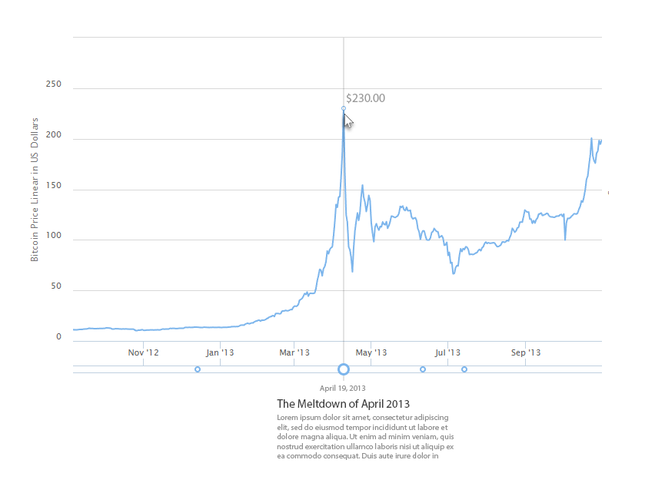

In terms of trade-offs one notable choice we decided to make was to not record the price for other cryptocurrencies on the timeline. This decision was made for a number of reasons both in regards to visualization issues as well as potential conflicts with our intended goal. Specifically, since many of the other cryptocurrencies have a much lesser value than Bitcoin, their changes in price are virtually invisible on a graph that scales to Bitcoin’s value. Additionally, we don’t want to overload the user with too much information if they’re not interested in pursuing it. The average layman will likely have a hard enough time understanding Bitcoin alone, adding other cryptocurrencies to the chart needlessly complicates things.

If this project was to be explored further, there are all sorts of features that would be worth adding. However, one notable feature that would bring a good deal to the chart without adding too much overcomplication would be some sort a comparison functionality. In other words, the ability to directly compare the various stats of Bitcoin at two different points on the chart could be an interesting tool for users to explore the data with. For example, it could allow the user to measure directly how much value was lost or gained in a particular crash or boom in Bitcoin’s history. While such comparisons could still be made with the visualization as is with a bit of math and memory, making such a feature more accessible would only add to the chart as a whole.

**Group Member Contributions (Since the last milestone)**

Eric:

Zoom/Pan feature - 5 hours

Graph auto scale/limits - 4 hours

Price tooltip - 4 hours

Video footage - 2 hours

Liam:

Event Collection - 5 hours

Event timeline implementation - 5 hours

Zoom buttons - 2 hours

Video Captions - 2 hours

Ke:

Data formatting - 2 hours

CSS/Aesthetics - 5 hours

Debugging - 4 hours

Information button - 2 hours